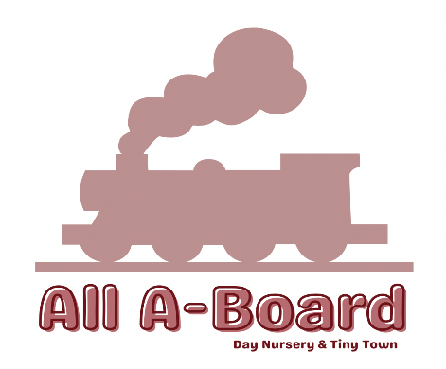

All fees are inclusive of the following and must be paid on the 1st of every month:.
- Extra Curricular Activities taking place throughout the day – such as cookery, physical education activities and forest school.
- Exclusive use of tiny town inside the premises with no outside visitors accessible.
- All milk is provided.
- All food and meals (for children who do not receive funding).

Your fees are calculated on a day rate, and therefore, your monthly invoice will fluctuate depending on the days your child attends the setting and the number of these days in a month.
Fees are due in advance, and we issue invoices one week from end of the month for the following month. Unfortunately, there can be no refunds for sickness or holidays.
Fees below are daily and are worked out using the above inclusive.
We also accept government funded places for children.
Session Time | Price
Standard Full Day | £85
Half Day AM | £45
Half Day PM | £45
Extra Hours | £8.50
Holiday Club Day | £40

Opening Hours and Attendance:
Monday – Friday 8:00am – 6:00pm
Standard Full Day – 8-6pm
AM Half Day Session – 8-1pm (Including Lunch)
PM Half Day Session – 2-6pm (Including Tea)
Minimum session policy of 4 half day sessions or 2 full days which is beneficial to children and their routine, developing bonds with other children and staff, ultimately creating happier environment for both parents and children.

Supplements For Funded Placements
Government funded children places are not inclusive of any meals, snacks, activities or extras, therefore a supplement will be added for children where needed to cover this.
Cost of classes can be enquired within the office.
Supplement Charges
For each child’s placement who receives funding there is an additional charge for all food supplements, the cost of supplements is charged monthly alongside the nursery monthly fees.
The cost of supplements is worked out in the table below, the supplements are displayed blow as a cost per day / per session.
Meal | Price | Half session
Breakfast | £2.50
Morning snack | £1.75
Lunch | £4.50
Afternoon snack | £1.75
Tea | £4.50
Total cost per day | £15 | £9

Registration Information
To register your child please follow procedures and all forms instructed by All A-Board Day Nursery.
- A registration fee of £50 is payable at time of registration (non refundable) and does not guarantee space and is based on availability at that time.
- A nursery place deposit of £150 is required on first day of settling in, which is refunded on final term of Childs placement.
- Once a placement offer has been made, we have a 3 day policy where place must be accepted before offer is given to next awaiting child.
- Payment made via BACS only.
- Settling in sessions are greatly valued by us, so we will be arranging those with you prior to your child placement starting date.

